PIC
  - Scada system description
Contents
1 Introduction 3
1.1 PIC controllers 3
1.2 Naming 4
1.3 Scada side 5
2 Interlock type 5
3 Widgets 6
3.1 CIPC widget 6
3.2 Synoptic widget 7
4 Faceplate 7
4.1 I/O Status 8
4.2 Powering 8
4.3 Monitoring 9
4.4 Params 9
4.5 Buttons 10
5 Configuration files 11
5.1 PVSSCMWServer_Diamon 11
5.2 Sector 11
5.2.1 LHCLoggingData_<sectors##> 11
5.2.2 CMWServer_Seq_CIP_<sector#> 11
5.2.3 LaserData_<sectors##> 12
5.2.4 qps_CIP_<sectors##>.txt 12
6 Import devices 13
6.1 External systems 14
6.1.1 SOFFE_ACCESS.txt 14
6.1.2 SOFFE_PP60A.txt 14
6.1.3 SOFFE_UPSOK.txt 14
6.2 Post mortem 14
6.2.1 WS_PM.txt 14
6.2.2 AS_PM#.txt 14
6.3 CIPC 15
6.3.1 pvss_CIP_<location>_<sectors##>.txt 15
6.3.2 SOFFE_SCRIPT_<sectors##>.txt 15
6.4 Cryo 15
6.4.1 PIC_CFP_<location>_<subsector>.txt 15
6.5 QPS 16
6.5.1 PIC_<qps_gateway_name>.txt 16
7 Manager setup 16
7.1 S7 16
7.2 LHCLogging 16
7.3 Laser 16
7.4 CMWServer 17
7.4.1 Status, Permit 17
7.4.2 Other 17
7.5 DIP 17
7.6 CMWClient 17
7.6.1 QPS and CRYO 17
7.6.2 Other 17
7.7 Ctrl 17
7.7.1 picScript_CB.ctl 17
7.7.2 Other 17
7.8 Archive 18
7.8.1 Sectors 18
7.8.2 Other 18
8 System Integrity 18
8.1 S7_PLC 18
8.2 SoftFE 18
8.3 CRC checking 18
9 Access control, File Access permission 18
10 Lock 19
11 External systems 19
11.1 CRYO maintain 19
11.2 CRYO start 19
11.3 UPS OK 20
11.4 QPS OK 20
11.5 AUG OK 20
12 Commands 20
12.1 Give/Remove permit 20
12.1.1 Functionality 20
12.1.2 Logic 20
12.2 Fast Abort command 21
12.3 Discharge request 21
13 Masking/unmasking 21
14 CMW interface 21
14.1 SIS 21
14.2 LHC Sequencer 22
14.3 PostMortem 22
14.3.1 Superlock Postmortem 22
14.3.2 Postmortem triggers 22
14.4 CRYO 22
14.5 QPS 22
15 Timing interface 22
15.1 Powering Permit 60A 22
15.2 Sector Access 23
16 Post-mortem 23
17 History buffer 23
18 Message Text 23
19 Global commands 23
19.1 From the panel 24
19.2 From CMW 24
20 Test bench in building 30 24
21 Repositories 24
21.1 Backup 24
21.2 Releases 25
22 DpType description 27
22.1 CIPC DpType 27
22.2 CIPC_CMD DpType description 30
22.3 CIPC_CRYOOK DpType description 30
22.4 CIPC_QPSOK DpType description 30
23 Interlocking flow chart 31

Introduction

PIC controllers
A PIC (Powering Interlock Controller) consists of a SIEMENS S7-319 PLC, patch panels for the connection of the client signals and some additional electronics for the interfacing of these signals to the PLC (ANYBUS I/O modules and a CPLDfor a redundant and fast reaction time for the beam dump signal).
The PLC part was not done by EN-ICE.
There is a genericPLC code present in each PLC, but with different configurations (defining the used interfaces and the beam dump and globakl protection functions of a given circuit - see chapter 23).
Each PIC controller is made of one PLC connected via Profibus to several electronic boards containing the remote I/Os. Therefore one PLC drives one PIC. A PLC can drive up to 56 circuits. In the whole LHC there are 36 individual instances of powering interlock controllers. In the LHC there are 28 powering sub-sectors. In general there is one PIC per powering sub-sector, except for the arcs (A## in Figure 2), where there are two PICs per powering sub-sector, one managing either side of the long arc cryostat.
One circuit is connected to one PIC controller. Only exception is RB circuits: they are always bound to two circuit controllers (i.e. two PIC) at the two ends (access points) of the sector: one is Odd (for odd points), one is Even (for even points).
Each sector has several S7-PLC Front Ends, each FE has only one PIC device.
Figure 1 - Architecture - the different levels of the project

Naming
Controller names are stored in the LHC Layout Database. Example:
CIP.UA47.AR4 = [Power Interlock Controller].[Zone UA47].[Arc Right from point 4]
The last part can be:
A = Arc ; X = inner triplets ; M = Matching (DFBM) , L = Matching (DFBL)
Signal names: each signal starts with a prefix. The prefix can be:
ST = status; CMD = command
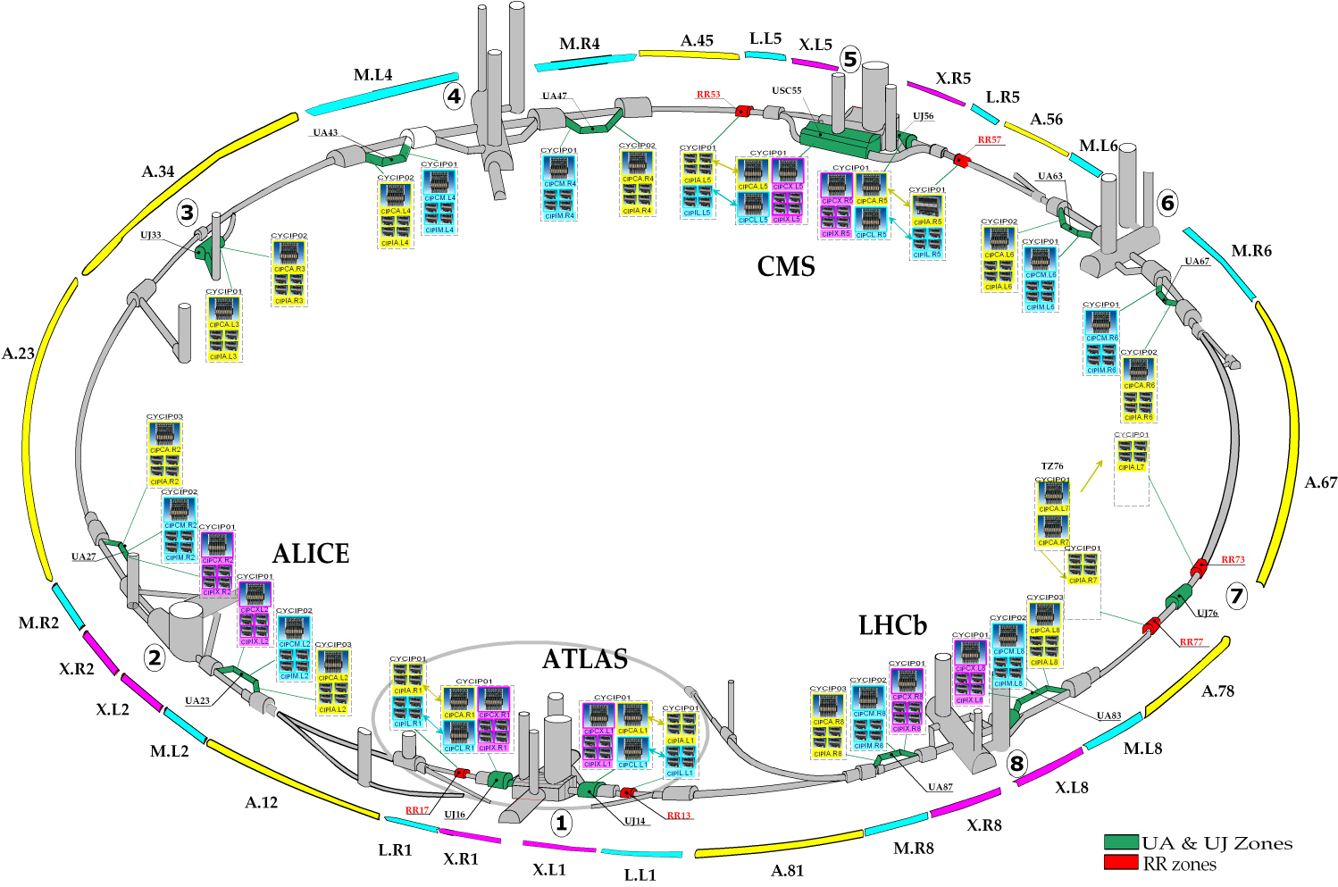
Figure 2 - PIC overview

Scada side
The SCADA only connects to the systems for monitoring for the critical protection functions. The SCADA only acts on the user's "allow startup" permit, including a number of non-safety-critical SW signals such as the QPS_OK, CRYO_O,... received via CMW and DIP as well as for the calculation of the PP60A. The rest of the automatic logic is implemented on PLC side.
Circuits are part of the PIC device. Data buffer (equivalent to Event list for CPC) is one per PLC.

Interlock type
Circuits vary in function of the type of interlock they are assigned to (Figure 3).
Exception: 10 circuits (CIP.AR3) are declared as interlock type B1 (due to the use of a standard 600A power conveter to overcome the voltage drop on teh long DC cable), however they have no QPS system attached adn consequently no QPS_OK signals.
Figure 3 - Circuit types and the maximum number of available interfaces in a CIPC device
The table below provides a summary:
Type | Max circuits per controller | Remarks
A | 3 | 1 of type RB (with link Even-Odd), 2 of type RQD, RQF or RQX
B2 | 5 | Individually powered quadrupoles, including two independent Power Permit I and II because of two power converters
B1 | 34 | Individually powered separation/combination dipoles + 600A corrector circuits
C | 12 | No QPS system, mainly 120A corrector circuits
D | - | 60A power dipole orbit corrector circuits - One bool value per sector (8 in total)

Widgets
Two types of widget: one per circuit (SYNOPTIC), one per controller (CIPC). The one per circuit is used only by the Unicos Circuit project.

CIPC widget
Used on PIC project only. There is one per controller, its status summarizes the status of the controller, showing a logic AND of the following signals: Unmaskable User Permit to BIS, Maskable User Permit to BIS, Powering Subsector OFF.

Figure 4 - Example of CIPC widgets, with the flags "old value" (left) and "forced mode" (right).
Symbol | Description
O | Old data (no connection with front end)
F | Forced mode (some signals masked)
A | ST Error or ST_Power failure
S | Failure on ST supply
C | ST_Connect failure
M | Multiple failures
Possible colours:
Colour | Description
Green | All OK
Orange | Bad status of Maskable User Permit to BIS
Red | Bad status of Powering Subsector OFF or Bad status of Unmaskable user Permit to BIS
Cyan | Old data (no connection with front end)
Purple | Device does not exist

Synoptic widget
The Synoptic widget is used by the Circuit project in order to visualize the PIC status for each circuit.
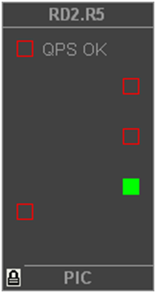
Permit I
Powering failure

Fast abort request

[Discharge request]

[Permit II]
QPS Ok

Circuit quench

[Discharge request]

Lock/superlock

Figure 5 - Example of Synoptic widget. In square brackets: elements not present in the example.

Faceplate
Only one faceplate, used on PIC project and on Circuit project.
The faceplate is divided into 4 tabs, described in the following paragraphs.

I/O Status
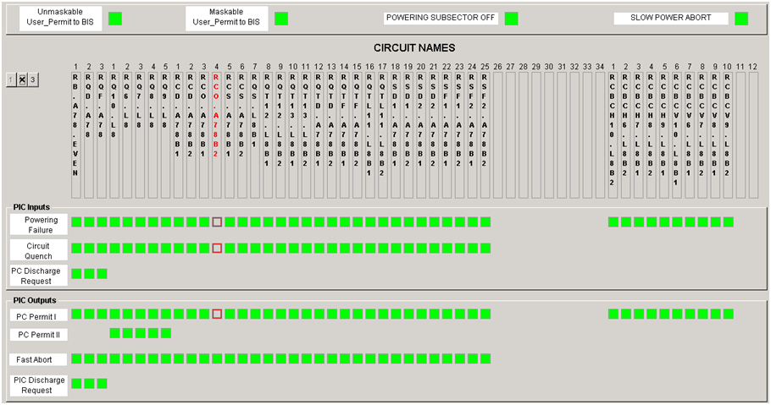
Type A
Type B2
Type B1
Type C
Figure 6 - The I/O Status tab. The circuits are grouped by interlocking type.
From PLC point of view. Global signals (on top) and signals per circuit are all monitored values from PLC. Their value represents hardware signals.
They are all for monitoring only, except Fast Abort and PIC Discharge Request (only when logged in with role PIC Experts allowed to do a SET on this property).
Signal | Description
Unmaskable User_Permit to BIS | Beam permit sent to BIS. It cannot be masked by BIS
Maskable User_Permit to BIS | Beam permit sent to BIS. It can be masked by BIS
Powering subsector off | Fast Power Abrot of all circuits in the subsectors
Slow permit abort | Slow power abort of all circuits in the subsector
The first two signals (User Permit to BIS) represent the local outputs of the individual PIC towards the close-by beam interlock controller. If a magnet circuit is switched off and depending on its importance for the beams to continue circulating, the PIC will inform the beam interlock controller, which in turn will take care of dumping the beams. Such signals appear also on the Params’ tab, showing how each circuit is mapping into these two signals (see 4.4).
Powering subsector off: POW_SUB_OFF = 1 means Ok for the whole CIP (it is On).

Powering
Monitors the powering permit status: Permit I (and Permit II for interlocks of type B2), Ready to Permit, QPS Ok.
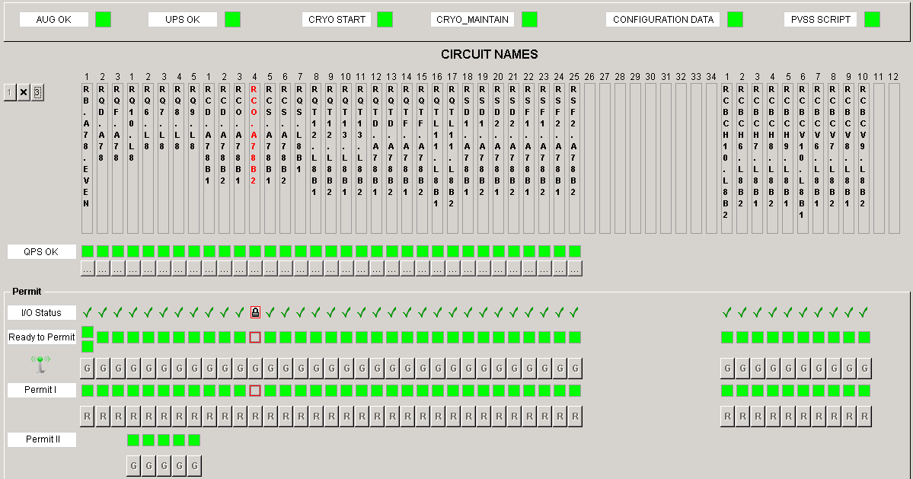
Figure 7 - The Powering tab
Allows giving (G) or removing (R) the powering permit (I and II). Giving Power PErmit is only possible if Ready to Permit is ok, while removing remains always possible.
Ready to Permit is based on I/O Status summary (taking into account the lock and super lock - see section 10) and the status of the external systems (AUG_OK, UPS_OK, CRYO_OK, CONFIG, PVSS SCRIPT, QPS_OK).
The status of teh input signals are surveilled at the PLC level with a cycle time of typically 1ms, and any false status of QPS, Poweringg Failure,... for each of the circuits will trigger a Fast or Slow Abort of the circuit. These actions are always performed at PLC level.
Signal | Description
AUG OK | Emergency stop status (Red buttons in LHC tunnel)
UPS OK | UPS status (both redundant systems OK)
CRYO START | Cryogenics start (more stringent conditions for startup of powering)
CRYO MAINTAIN | Cryogenics maintain (conditions to maintain circuit powering)
CONFIGURATION DATA | Configuration data versions in PVSS and PLC are consistent
PVSS SCRIPT | PVSS scripts are running
QPS OK | Quench Protection System is ok (fully redundant, heaters charged,..)
I/O Status | Lock/unlock functionality
Ready to Permit | All external and internal conditions are met to allow for circuit powering (ie giving Power Permit)
Permit I | Power Permit towards power converter
Permit II | Power Permit towards power converter (available only for circuit type B2)

Monitoring
Monitoring values coming from PLC. For experts, it is possible to send bit-commands to the CPLD of the PIC in order to get some information messages.

Params
It shows the config in the PLC. The filled squares indicate the reaction(s) foreseen in case the circuit is in error. The flags PIC_UNM and PIC_MSK will define on which of the two signals Unmaskable User_Permit to BIS and Maskable User_Permit to BIS a failing circuit will have an effect (see 4.1 for more info on those signals).
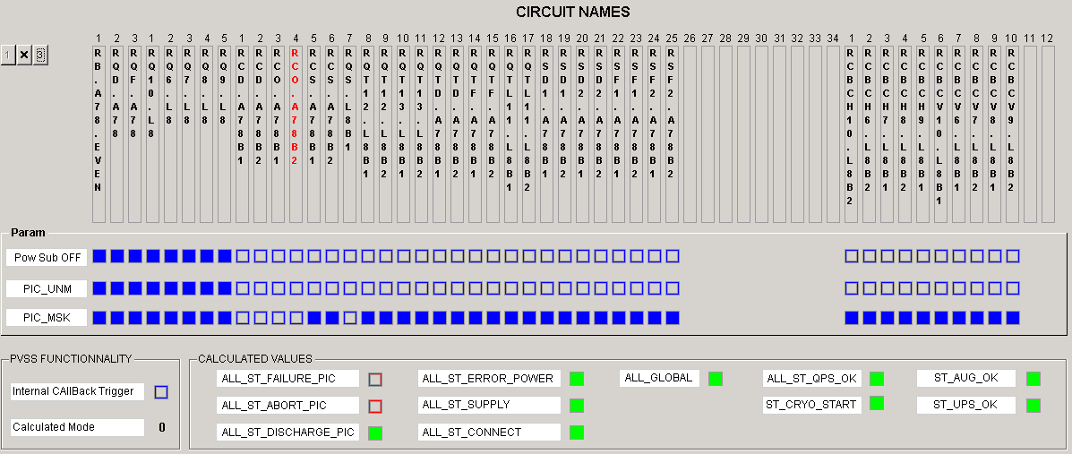
Figure 8 - The Params tab
If PIC detects a problem on a circuit, it can request a beam dump to BIS.
Under Calculated Values, a set of parameters it monitored (summary of other parameters).
Signal | Description
Pw Sub OFF | Powering Subsector Off
PIC_UNM | Unmaskable User_Permit to BIS (Beam Interlock System).
PIC_MSK | Maskable User_Permit to BIS (Beam Interlock System).
In the example of Figure 8, the circuit RB.A78.EVEN will raise the flags Pow Sub Off, PIC_UNM and PIC_MSK; the circuit RCO.A78B1 will not do anything.
The RB.A78.EVEN circuit is vital for the beams to circulate, therefore it has both flags PIC_UNM and PIC_MSK set and if it fails it will remove both signals Unmaskable User_Permit to BIS and Maskable User_Permit to BIS, therefore the beams will be dumped irrespective from the intensity/energy.
The RCS.A78B1 has only the PIC_MSK flag set, thus it will only remove the Maskable User_Permit to BIS. Therefore a maskable BIS input, as the name says, can be MASKED at the BIS level under certain circumstance, namely if the beam is considered to be safe (i.e. it does not have the potential to damage the machine). So under these circumstances it is allows to continue operating even if not all circuits are operational.
The RCD.A78B1 has currently none of the flags set. This means it will not affect any signals towards the BIS, therefore the beams will never be directly dumped, one can even run without this circuit powered.

Buttons
Select: manages the Unicos lock in PVSS. Allows enabling the buttons of the faceplate in order to guarantee exclusive access to the commands of the PVSS panel (faceplate).
Signal Init: Allows reinitializing the PLC logic, ie to attempt to clear latched faults on a circuit (it is not a warm restart!).
Forced Mode: manage mask/unmask external systems values (AUG_OK, UPS_OK, QPS_OK...).
CMW server: start/stop the CMW server manager that publishes the status of the sector.
Give Multiple: gives permit to all the circuits where Ready to Permit is ok.
Remove All: removes permit to all the circuits.

Configuration files
These files are loaded on manager start and do not need to be manually imported.
The table below summarizes the configuration files and their sources
File | Source | Generator | Description
PVSSCMWServer_Diamon | Done manually | - | Diagnostics
LHCLoggingData_<sectors##> | AB/CO Database | PL/SQL script | LHC logging
CMWServer_Seq_CIP_<sector#> | AB/CO Database | PL/SQL script | CMW servers
LaserData_<sectors##> | AB/CO Database | PL/SQL script | Laser data
qps_CIP_<sectors##>.txt | AB/CO Database | PL/SQL script | QPS OK
Here follows a more detailed description of each file.

PVSSCMWServer_Diamon
Configuration file for the system alarm list (system integrity) to be published to the monitoring system (Diamon). One for the whole project.
Example: pic\data\PVSSCMWServer_Diamon
- [PVSS.PIC_1.DIAG.ALARM]
- dpe=pic_1:_unSystemAlarm_CMWClient_20.alarm
- alias=
- property=CMWCLIENT_20
- direction=out
- value=long
- time=longlongnano
- ...

Sector

LHCLoggingData_<sectors##>
Config file with the list of data to be sent to the long term archiving DB (LHC Logging).
There is one file per sector. It is used to define the data, which should be sent to the LHCLogging service. The internal LHCLogging Configuration must be done with a PVSS administrator.
Files in SVN, under the LHC_INTERLOCK project.
Example: pic\data\S12\LHCLoggingData_12
- [_ValueArchive_9]
- dpe=
- alias=CFP_UA23_CIPAL2/CMD_PLC_RESTARTED/HB
- name=CFP_UA23_CIPAL2:CMD_PLC_RESTARTED
- description=PLC RESTARTED
- hierarchy=<node name="LHC"><node name="Powering Interlocks"><node name="CIP.UA23.AL2"></node></node></node>
- format=
- ...

CMWServer_Seq_CIP_<sector#>
Config file for defining the publications of the CIP status/command (used by the LHC sequencer).
There is one file per sector. It is used to define a CMW server in order to allow remote control of the PIC through the Sequencer. It allows publishing PIC data. The internal CMWServer configuration must be done with a SCADA administrator.
Example: pic\data\S12\CMWServer_Seq_CIP_1
- [PIC.PVSS.RQX.R1]
- dpe=
- alias=RQX.R1/ST_DISCHARGE_PIC
- property=ST_DISCHARGE_PIC
- direction=out
- value=boolean
- time=longlongnano
- ...

LaserData_<sectors##>
Config file with the list of process alarms to be sent to the Laser system (centralized alarm system).
There is one file per sector. The Laser Configuration must be also done with a SCADA administrator.
Example: pic\data\S12\LaserData_12
- [BOOLEAN]
- dpe=
- alias=CIP.UJ16.AR1/ALL_ST_FAILURE_PIC
- name=
- range=0; description=""; ff=LHC_PIC; fm=CIP.UJ16.AR1; fc=1; state=ACTIVE;
- range=1; description=""; ff=LHC_PIC; fm=CIP.UJ16.AR1; fc=1; state=TERMINATE;
- ...

qps_CIP_<sectors##>.txt
QPS OK signal. There is one file per sector. It allows checking that all the QPS agents are well defined in the PIC supervision.
Example: pic\data\S12\QPS_Ok\qps_CIP_12.txt
- [RB.A12]
- MB.A10L2
- MB.A10R1
- MB.A11R1
- ...
To check the configuration, open a PIC faceplate, go to the Powering tab, click on a QPS_OK button, then on the Check button (Figure 9). A new panel will popup and you have to select the file. Click on check to start the checking process.
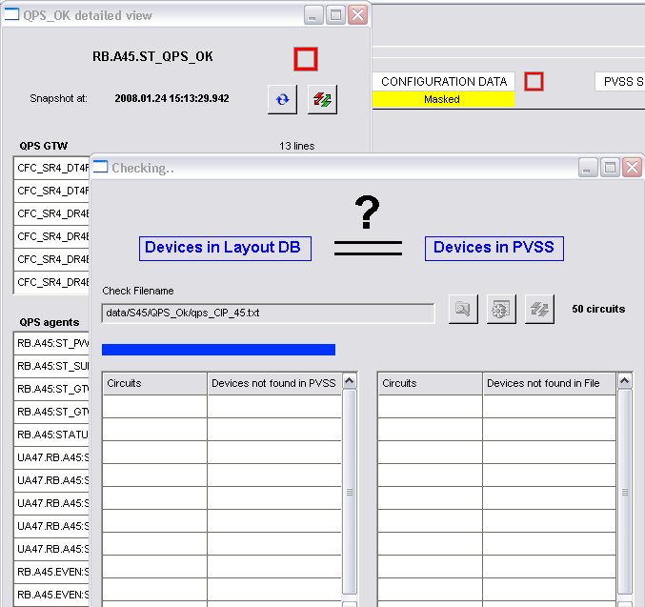
Figure 9 - QPS_OK configuration check panel

Import devices
The table below summarizes the db import files and their sources
File | Source | Generator | Description
SOFFE_ACCESS.txt | Done manually | - | Access permit
SOFFE_PP60A.txt | Done manually | - | PP60A permit
SOFFE_UPSOK.txt | Done manually | - | UPS OK
WS_PM.txt | Done manually | - | Post mortem
AS_PM#.txt | Done manually | - | Post mortem conf.
pvss_CIP_<location>_<pwSubsectors##>.txt | AB/CO Database | PL/SQL script | CIPC devices
SOFFE_SCRIPT_<sectors##>.txt | Done manually | - | Scripts counters
PIC_CFP_< location >_< pwSubsectors>.txt | Done manually | - | Cryo
PIC_<qps_gateway_name>.txt | AB/CO Database | QPS script | QPS
Here follows a more detailed description of each file.

External systems

SOFFE_ACCESS.txt
LHC Access script.
Example: pic\data\SOFFE_ACCESS.txt
- #Delete;SOFT_FE_1;APPL;
- PLCCONFIG;SOFT_FE;SOFT_FE_ACCESS;SECTOR_ACCESS;Y;
- # Device type: WordStatus
- WordStatus;2;ACCESS_Calculated;Calculated Sector Access bits;;;;;;WordStatusBit;;###;300.0;0.0;O;0;;;;
- ...

SOFFE_PP60A.txt
Script for the Power Permit of the 60A.
Example: pic\data\SOFFE_PP60A.txt
- #Delete;SOFT_FE_1;APPL;
- PLCCONFIG;SOFT_FE;SOFT_FE_PP60A;PP60A;Y;
- # Device type: WordStatus
- WordStatus;1;PP60A;Value for the 60A Power Permit;;;;;;WordStatusBit;;###;300.0;0.0;O;0;;;;
- ...

SOFFE_UPSOK.txt
UPS status check.
Example: pic\data\SOFFE_UPSOK.txt
- PLCCONFIG;SOFT_FE;SOFT_FE_UPSOK;UPSOK;Y;
- # Device type: WordStatus
- WordStatus;1;E_PIC_UPS_LHC1;Logical sum of UPSName_OK and UPSName_FLT for Sector 12;diag;html;def;S12;;WordStatus;;#;9.0;0.0;O;0;;;;
- ...

Post mortem

WS_PM.txt
For the PP60A status (8-bit words) and Sector Access status.
Example: pic\data\POST_MORTEM\WS_PM.txt
- PLCCONFIG;SOFT_FE;SOFT_FE_PM;POST_MORTEM;N;
- WordStatus;1;PM_MODE;;;;;XTIM;PM1;WordStatusBit;;;0.0;0.0;A;0;;;;

AS_PM#.txt
Value of the Post-mortem Trigger (time in ns).
Example: pic\data\POST_MORTEM\AS_PM1.txt
- #Delete;PM1_CMW_FE;POST_MORTEM;
- #FRONT-END;FE type;FE name;FE application;FE CMW type;FE CMW transf type;Polling group,valuePollingTime;CMW device;CMW property;CMW tag;FilterName;FilterValue;LLC (llc[,GeneralQuery]);
- PLCCONFIG;CMW;PM1_CMW_FE;POST_MORTEM;2;1002;;XTH.PM1-XTIM;Acquisition;acqC;;;FALSE,FALSE;
- #AnalogStatus;ObjectNumber;Alias;Description;Diagnostic;Html;DefaultPanel;Domain;Nature;widget;Unit;Format;Deadband;DeadbandType;RangeMax;RangeMin;ArchiveActive;ArchiveTimeFilter;Type;Transformation Type;PollGroup,Time poll;CMW Device;CMW Property;CMW Tag;filterName;filterValue;LLC;
- AnalogStatus;1;PM1_ACQUTC;Reserved for operational PM triggers, get Trigger UTC Time in seconds as long;;;;XTIM;PM1;AnalogStatusWide;;9EXP;#VALUE!;0;0.0;0.0;A;0;2;1002;;XTH.PM1-XTIM;Acquisition;acqUTC;;;FALSE;

CIPC

pvss_CIP_<location>_<sectors##>.txt
Import is done using the S7 manager number. Archives: Bool, Analog are set to System. Event is set to CIPC_<sector#>.
Example: pic\data\S12\pvss_CIP_UA23_AL2.txt
- #PLCCONFIG;PLCType;PLCName;PoweringSubsectorName;Local_ID(hex);Local_Rack;Local_Slot;Local_ConnectionRessource(hex);Partner_Rack;Partner_Slot;Partner_ConnectionRessource(hex);Timeout(ms);PLC_IP;address_IP;address_counter;address_CommandInterface;address_PLCInfo;address_version;gen_version;value_PLC_HWcheck,value_PLC_SWcheck,value_PLCversion,value_Maskcheck,value_Maskversion,address_PLC_HWcheck,address_PLC_SWcheck,address_PLCversion,address_PIC_ID,address No. Restarts;
- ...
- #DeviceType;deviceNumber(unique);deviceName(PVSS Alias);Powering Subsector (Description);[diagnosticPanel];[html page];[default panel];Building+Circuits;Interlock Type+Circuit Type;widget;Pow Sub OFF;Global SPA;Ess Circuits;Aux Circuits;First Scan Latch;Cryo PLC OK;Cryo PLC Com;UPS OK;AUG OK;ST_MATRIX_BIT_1;ST_MATRIX_BIT_2;ST_MATRIX_BIT_3;ST_MATRIX_BIT_4;ST_MATRIX_BIT_5;ST_MATRIX_BIT_6;ST_MATRIX_BIT_7;ST_MATRIX_BIT_8;ST_CONNECT_CIPPA/B1;ST_CONNECT_CIPPB1/B2;ST_CONNECT_CIPPB2/B3;ST_CONNECT_CIPPB3/B4;ST_CONNECT_CIPPC/B5;ST_CONNECT_CIPPS;ST_LOOP_ESS_CIRCUITS;ST_LOOP_AUX_CIRCUITS;ST_SUPPLY_24V_1;ST_SUPPLY_24V_2;ST_SUPPLY_5VELEC_1;ST_SUPPLY_5VELEC_2;ST_SUPPLY_5VBUS_1;ST_SUPPLY_5VBUS_2;ST_MATRIX;ST_ERROR_ANY_1;ST_ERROR_ANY_2;ST_ERROR_ANY_3;ST_POWER_ANY_1;ST_POWER_ANY_2;ST_POWER_ANY_3;ST_PWR_PERM_AUG;ST_PWR_PERM_UPS;ST_BEAM_PRESENCE;ST_SUPPLY_PLC_1;CMD_RESET_ANY_1;CMD_RESET_ANY_2;CMD_RESET_ANY_3;CMD_A0;CMD_A1;CMD_A2;CMD_A3;CMD_A4;CMD_R_W;COMMAND_RESET_ANY_1;COMMAND_RESET_ANY_2;COMMAND_RESET_ANY_3;COMMAND_A0;COMMAND_A1;COMMAND_A2;COMMAND_A3;COMMAND_A4;COMMAND_R_W;Signal Init;PARAM_PS;PARAM_BD;PARAM_BD_Aux;Cryo_Comm_Enable;Event Archive;Boolean Archive;
- ...
- #PVSS Device Type;deviceNumber;Circuit Index;Circuit Type;Circuit Name;ST_FAILURE;ST_ABORT;ST_DISCHARGE;CMD_PWR_PERM;CMD_ABORT;CMD_DISCHARGE_FOR_A/CMD_PWR_PERM_B2FOR_B2;Action_Fast_Abort;Action_Discharge_Request;Give Permit I;Give Permit II;Remove Permit;Description;
- ...

SOFFE_SCRIPT_<sectors##>.txt
Soft front end just to create a counter that allows checking that the scripts are running.
Import is done using driver #20, archives are all set to System.
Example: pic\data\S12\SOFFE_SCRIPT_12.txt
- #Delete;SOFT_FE_SCRIPT_11;S12;
- PLCCONFIG;SOFT_FE;SOFT_FE_SCRIPT_11;S12;Y;
The ctrl manager #11, running picScript_CB.ctl, writes the heartbeat counter on the device SOFFE_SCRIPT_11 for the System Integrity check.

Cryo

PIC_CFP_<location>_<subsector>.txt
Config for the input of the CRYO_OK signal.
Example: pic\data\S12\Cryo_Ok\PIC_CFP_SHC18_ARC12.txt
- PLCCONFIG;CMW;CIPC_CFP_SHC18_ARC12;ARC12;2;1003;;cryo.S12.WATCHDOG;ARC;value;;;FALSE,FALSE;
- #format: CIPC_CRYOOK;Device number;Device name (Device Identifier);description;Diagnostic panel;HTML page;Default panel;subsystem1 (Domain);subsystem2 (Nature);Widget Name;CMW Device;[[archive bool];[archive analog];[archive event];]
- CIPC_CRYOOK;1;CIP.UJ16.AR1_CRYO_OK;Cryo Start Interlocks for Powering Subsector AR1;diag;html;def;AR12;;CRYOOK;cryo.S12.CryoStart;
- ...

QPS

PIC_<qps_gateway_name>.txt
QPS signals.
Example: pic\data\S12\QPS_Ok\PIC_CFC_SR1_DR1BC_IP1_DR1B_A12.txt
- # Device type: CMW
- #format: Delete;Front-end device name;Front-end application (or *);[Device type;[Device id;]]
- #Delete;CIPC_CFC_SR1_DR1BC_IP1_DR1B;A12;
- #format: PLCCONFIG;CMW;Front-end device name;Front-end application;;;;CMW Device;CMW Property;CMW Tag;;;;
- PLCCONFIG;CMW;CIPC_CFC_SR1_DR1BC_IP1_DR1B;A12;2;1003;;QPS.PIC.PVSS.CFC-SR1-DR1BC_1;COUNTER;value;;;FALSE,FALSE;
- # Database PVSS generated at 2007.12.13 10:33:09.886
- # Device type: DQAMCMB
- #format: CIPC_QPSOK;Device number (unique, WorldFipAgent Number);Device name (Device Identifier);description;Diagnostic panel;HTML page;Default panel;subsystem1 (Domain);subsystem2 (Nature);Widget Name;CMW Device;[[archive bool];[archive analog];[archive event];]
- CIPC_QPSOK;10050;CIPC_MB.A10R1;DQAMC type MB for dipole MB.A10R1;diag;html;def;RB.A12;DQAMCMB;QPSOK;QPS.PIC.PVSS.MB.A10R1;

Manager setup
The PIC project is unique for all the LHC and in most of the cases it has been internally divided by sector. The following table lists the Manager numbers according to the sector:
Sector | S7 | CMWClient | Ctrl | Archive | LHCLogging | LHCLaser | CMWServer
Sector 12 | 11 | 21 | 11 | 9 | 21 | 31 | 41
Sector 23 | 2 | 22 | 12 | 8 | 22 | 32 | 42
Sector 34 | 3 | 23 | 13 | 4 | 23 | 33 | 43
Sector 45 | 4 | 24 | 14 | 3 | 24 | 34 | 44
Sector 56 | 5 | 25 | 15 | 5 | 25 | 35 | 45
Sector 67 | 6 | 26 | 16 | 6 | 26 | 36 | 46
Sector 78 | 7 | 27 | 17 | 7 | 27 | 37 | 47
Sector 81 | 8 | 28 | 18 | 2 | 28 | 38 | 48

S7
One driver per sector. Each driver connects several PLCs.

LHCLogging
One manager per sector. Publish events to LHC logging db. A restart is not harmful, as Timber gets messages every 5 minutes. It does not require the call of the expert.

Laser
One manager per sector. Publish alarms to Laser (non-PVSS alarms archiving). The manager can be restarted without any serious consequence.

CMWServer

Status, Permit
One manager per sector. Publish every CIP status, receive Give Permit / Remove Permit commands from Java UI (SIS, LHC Sequencer, Postmortem). If restarted, the connection with the Java utilities is temporarily lost and the CCC won’t be able to control the PIC. The CCC must be therefore warned of every restart.

Other
Man Number | Description
2 | Get/set 60A+Access status Enable/Disable (see flowchart) from/to Java user interface.
10 | Publish System Integrity to DIAMON

DIP
DIP connection provides the UPS_OK status. Data can be flagged as Invalid (“N”) if the invalid bit is set (the user bits are not used).

CMWClient

QPS and CRYO
One CMW client per sector. Input from QPS and CRYO status.
Input from QPS: data to calculate the QPS_OK and HDS interlock remove permit request.
Input from CRYO: CRYO_OK signal. If the manager is restarted, there is a chance to bring the QPS and CRYO signals to bad state (the counter for the System Integrity is checked every 30s: if the restart takes less than 30s, it should be harmless).

Other
Man Number | Description
20 | For 60A + Access communication through Timing bus. Output to 60A and Access devices after flow chart computation. A restart is delicate: if during restart a status changes, it is not sent again after restart. In that case the status must be refreshed manually.
30 | Post Mortem input.

Ctrl

picScript_CB.ctl
One manager per sector. Man numbers define the sector. Do all the inputs calculations. The input values are all concerning PLCs, QPS (QPS_OK, HDS), UPS, CRYO. The output values are not to PLC. Features the Ready to Permit. During the restart of a ctrl manager of a sector, the ready to permit corresponding to the sector will be down for a few seconds. The permit remains unchanged, but it cannot be given in case it used to be down.

Other
Script name | Description
picScript_PP60A.ctl | Script for 60A devices. Checks for alarms or if enabled or if fast abort. Flow chart computation. Output to P60 devices. The 60A Power Permit systems have around 900 Power Controllers, grouped in sectors. They are controllable from the PIC as 8 groups. The ctrl script picScript_PP60A.ctl makes a 8-bit status word per sector:  bit 1 = sector 1-2, bit 2 = sector 2-3...  The status word is in a dp of type WordStatus, dpe ProcessInput.AuPosRSt. The CMW sends the word to Timing Bus. It gets the readback value for confirmation.
picScript_Access.ctl | Script for the 8 sectors access: check if there is access. Flow chart computation. Output to Access devices.
picPMTrigger.ctl | Script for Post Mortem. Gets the trigger for Post Mortem. PM data is sent through TCPIP (CMW but without driver).

Archive

Sectors
One manager per sector.
Sector | Manager Number | Archive name | Dpes | Number
Sector 12 | 9 | CIPC_11 | 2600 | 3500
Sector 23 | 8 | CIPC_2 | 1800 | 3000
Sector 34 | 4 | CIPC_3 | 1300 | 4000
Sector 45 | 3 | CIPC_4 | 2200 | 2500
Sector 56 | 5 | CIPC_5 | 2500 | 2000
Sector 67 | 6 | CIPC_6 | 1400 | 4500
Sector 78 | 7 | CIPC_7 | 1800 | 3000
Sector 81 | 2 | CIPC_8 | 1800 | 3000

Other
Description | Manager Number | Archive Name | Dpes | Number
UNICOS (message text from operator actions) | 0 | UNICOS | 220 | 20000
System Integrity | 1 | System | 450 | 11000
System Integrity statistics | 10 | Statistics | 500 | 500

System Integrity
The System Integrity is fully based on the standard UNICORE component. The PIC project is configured to manage the system alarms of all the managers.

S7_PLC
During the import of the CIP instances, the S7_PLC front end definition is imported and the system alarm is also generated in the System Integrity (standard UN feature).

SoftFE
The Soft Front Ends are mandatory to be able to monitor the correct working of the ctrl scripts (Soft FE provides the counter dpe).

CRC checking
PIC functionality. It verifies that the PLC device config version is equal to the PVSS device config version (CIPC dps, dpe: Configuration.IN_PLC, IN_PVSS). It is triggered at least every hour on each CIP. The result of the check is written into the dpe _unSystemAlarm_import_* (UNICORE standard). The basic functionality of the system integrity with the Import check is disabled.

Access control, File Access permission
The following table summarizes the Access Control privileges.
The configuration (domains, groups) is done on installation of the component.
The users list is done from the Circuit project, which synchronizes all the QPS and PIC projects. New users can be added only from the Circuit project. ROOT user has access only to the AC configuration: no rights for operation.
File Access permission is using the standard UNICORE feature, defined on installation.

Lock
If Ready to Permit signal (I, and II if present) is ok, the operator can manually allow the powering permit of the circuit (button G on Powering tab of the faceplate).
Such operation can be temporarily disabled (lock) or enabled (unlock) by the operator.
The SuperLock has the same feature as Lock, but setting/resetting requires a higher user privileges. Such action (set Superlock) also needs a comment to be added.

External systems

CRYO maintain
Heartbeat counter. It concerns the communication between CRYO PLC and PIC PLC. The SCADA only monitors such value.
The CRYO PLC is incrementing a value (heartbeat), monitored in PIC PLC in order to verify that the communication is running correctly. If not, the PIC PLC will reset the CRYO MAINTAIN signal and trigger the power abort. The no-heartbeat signal can be masked in the PLC via STEP7 and not via the SCADA (see chapter 13).

CRYO start
Data received from the CRYO SCADA through CMW.
The data is stored into the dp of type CIP_CRYOOK, dpe: ProcessInput.ST_CRYO_START. The data is then computed by a script and the output is written into the dp of type CIPC, dpe: ExternalSystems.CRYO[1] (CRYO_OK). The computation is done by the script picScript_CB.ctl, calling the lib picExtSystem, function CB_CryoStart. It copies the value of CRYO_START only if there is connection to PLC. Else, the value becomes false.

UPS OK
The data comes from TIM through DIP.
Same principle as for CRYO start (see par. 11.2). The input values are stored into the dp of type WordStatus, dpe ProcessInput.AuPosRSt. ). The ouput is stored into the dp of type CIPC, dpe: ExternalSystems.UPS. Each circuit is bound to the UPS of PIC and of RTU (electricity front ends) of the same sector where the circuit is installed. The logic is as follows:
UPS_OK = UPS AND RTU AND DIP counter incrementing AND UPS scripts counter incrementing

QPS OK
Data received from the QPS SCADA through CMW.
Same principle as for CRYO start (see par. 11.2). the input values are stored into the dp of type CIPC_QPSOK (the dpes inside ProcesssInput). The ouput is stored into the dp of type CIPC, dpe: ExternalSystems.QPS. Each circuit can be connected to several (up to hundreds) QPS agents. The computation is done by the script picScript_CB.ctl, calling the lib picExtSystem. The output of the computation is also written into the dpe ExternalSystems.QPS_INFO, as reduction of the error list to be displayed on the HMI.

AUG OK
Monitoring (from PLC) of the AUG status. It can be masked (DISABLE) only on SCADA side (not on PLC).

Commands
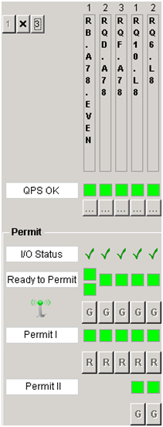The PIC also removes the Permit (allow startup) in case of circuit problem. This can be re-set only by an operator, provided that the circuit is back to normality. This is done with PVSS.
Figure 10 - Give/remove Permit
The signals sent by PVSS to PLC are all pulses of logic level 1, lasting 2s. The PLC detects only the raising edge of the pulse, ignoring the state.

Give/Remove permit

Functionality
The permit allows starting powering a circuit. It does not power the circuit directly.
The command is sent by the operator from either PVSS (by clicking on the G button in the PIC faceplate - see Figure 10) or Java applications (LHC Sequencer). The Java application sends the command through CMW (see chapter 19). It also gets the Ready to Permit signal from PVSS (CMW).
The Permit can be removed at any time (button R or command from Java application).

Logic
The permit is possible if the circuit signal Ready to Permit is ok, and if there is no lock set (see Figure 10). If the permit is given by the operator, the Permit I (and Permit II if exists) become ok.
The Remove signal does not make any check, it can reset the Permit I (and II) at any time.

Fast Abort command
Upon user command, the signal is sent from the SCADA to the PLC. IF applicable (ie the global protection flag activated) The PLC propagates the signal to all the circuits of the CIP in order to turn them off.

Discharge request
Upon user command, the signal is sent from the SCADA to the PLC. The PLC propagates the signal to all the circuits of the CIP in order to discharge the circuit’s energy (by activating the energy extraction systems).

Masking/unmasking
Masking is possible for many of the signals involved in the computation of the Ready to Permit interlocking signal. The masking window can be opened by clicking on the button Forced Mode.
The following signals can be masked:
AUG OK, UPS OK, QPS OK, CRYO START, CRYO MAINTAIN (not from the SCADA), CONFIGURATION DATA, PVSS SCRIPT, PLC DATA connection.
An example is visible in Figure 11.
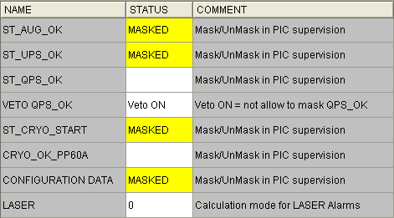
Figure 11 - The masking window.
VETO QPS OK: Enable/disable masking of the QPS OK. Veto On = masking not allowed. This can be done only by users belonging to the group interlock_admin_expert.
CRYO MAINTAIN: Masking is read only from the PLC. The flag can be set only from the Step7 interface. The reading of the masking can be seen also from the Monitoring tab on the faceplate (ST_CRYO_ENABLE - see par. 4.3).
The masking is also summarized on the main HMI panel.

CMW interface

SIS
The Software Interlock System is a Java application managing more complex interlock logic functions to enhance the LHC safety. It gets information on the LHC status (e.g. access conditions...) and sends an interlock signal to other applications. It can send a LOCK or UNLOCK signal to the PIC SCADA, through CMW (see par. 19.2). It does a “Set of Sector Access PIC Enable” as visible from the panel Sector Access.

LHC Sequencer
A Java application. It reads the status of each circuit and is used to remotely pilot the LHC magnet powering system and its associated interlock system (PIC). It can send the signals give permit, remove permit, signal init (+ Fast Abort & Discharge Requests for HWC purposes) but not using the global command: it accesses directly the dpes. It can be used to fully control the PIC remotely.

PostMortem

Superlock Postmortem
The Postmortem system can set the superlock on any circuit, if the analysis of teh preceding circuit failure status is not validated. Commands currently available: SUPERLOCK and UNSUPERLOCK. Command received by the CMW servers (see par. 19.2).

Postmortem triggers
Postmortem trigger (CMW manager 30). It sends the Postmortem trigger time (in ns). Once PIC gets the trigger, it waits 30s, then queries the history buffer (event list) 90s back in time. It sends the query result to the postmortem server. It is a DLL (post-mortem.dll).

CRYO
PIC subscribes to the CRYO_OK data (one per CIP).

QPS
It sends global commands (REMOVE_PERMIT) when HDS problems are detected in QPS side.
PIC subscribes also on the QPS status to calculate the signal QPS_OK (one signal per circuit).

Timing interface
The Timing Interface is a chain of communication interfaces. The PIC has control of the 60A Power converters through the communication channel as shown in Figure 12.
Figure 12 - The communication channel to PP60A.

Powering Permit 60A
The LHC features a total of 752 60A Dipole orbit corrector circuits distributed equally in the 8 sectors. They are controllable from the PIC as 8 groups. The ctrl script picScript_PP60A.ctl makes an 8-bit status word per sector. The bit = 1 means powering permit for all the 60Amps power converters in the sector corresponding to the bit number. Example: 00000001 gives permit to all the 60A power converters of the sector 1-2 (Figure 12).
The logic is done such that the permit is not removed if the beams are circulating to avoid large orbit changes due to the simultaneous loss of up to 94 circuits (ST_BINFO_B1B2). In addition, if by mistake the permit is removed by the PIC SCADA while beams circulate, the Timing Bus rejects the "permit Off" message. The read-back is done only at CMW level (the PIC does not know if the Timing server correctly sent it). The permit is a Start/Stop interlock: it powers on or off the 60A Power Converters immediately. The logic is done on PVSS side. On the PLC there is no logic regarding the PP60A.
The CMW client for the PP60A is very delicate: if a permit state changes during the restart of the client, the status it is not sent after reconnection! In this case, a mismatch in the permit status can be detected on the interlock logic panel (double-click on the PP60A table). The Refresh button resends the current status.

Sector Access
Same principle as the PP60A (se par. 15.115.2).
Each bit of the word corresponds to a sector. It allows operators to give short expert access to the LHC without the need to completely switch off the LHC circuits by limiting the current in all circuits <1kA (and 100A for the main dipole circuit.

Post-mortem
Command coming from CMW (dp of type AnalogStatus). Processed by ctrl script picPMTrigger.ctl that makes use of dll CtrlPostMortem.so (the windows version, .dll, is a fake). The output is sent by the functions defined in the dll, through CMW.
The post mortem trigger consists of 3 signals: one for the UTC time, one for the nanoseconds and one for the triggers counter. There are two post mortems, one is for production (number 1), one is for testing (number 2).
The PIC SCADA, once received the PM trigger, waits for 30s, then sends the event history buffer of the last 1m30s.
The PM trigger is visible on the message text viewer (type INFO, text pattern: *PM*).
If PIC is not able to send the PM buffer (communication error detected by the dll) the data is written in the disk into the folder data/, using the UTC timestamp.

History buffer
Several types of Surce:
Globals: CIP signals going to PLC, one for several circuits. The ones coming from other sources(i.e. DIP…) are not classified as Globals but as External Systems.
Externals Systems: signals coming from external systems (i.e. AUG coming from DIP…). They are not directly connected to the PLC but directly to PVSS (via DIP, CMW).

Message Text
Also called Actions Logbook. When PP60A sends a set, it adds a message to the log. The message is typically:
FAILED to Set PP60A - Value: 0 - Forced: TRUE 0
FAILED = message rejected.
Value = the value of the message (255 = all On).
Forced = if TRUE it forces the value to be send even if it did not change since last time.
0 = Number of tries. It tires every 10s, for 3 times.

Global commands
The SCADA can receive commands from the operator interface (i.e. buttons) or from another external system (messages send through CMW).

From the panel
Command directed to CIP.
DPE: <CIP DpName>.InternalFlag.INTERNAL_CMD. List of possible commands:
- <host name>,<user name>~LOCK
- <host name>,<user name>~UNLOCK
- <host name>,<user name>~GIVE_PERMIT
- <host name>,<user name>~REMOVE_PERMIT
- <host name>,<user name>~SIGNAL_INIT

From CMW
The message can arrive from LHC Sequencer, SIS (Software Interlock System), or Postmortem. It is directed to CIP or to a single Circuit.
CMW config: data\Sxy\CMWServer_Seq_CIP_x
CMW: device name: PIC.PVSS.<CIP NAME> property name: GLOBAL_CMD
DPE: <CIP DpName>.InternalFlag.INTERNAL_CMD
List of possible commands:
- <host name>,<user name>~LOCK
- <host name>,<user name>~UNLOCK
- <host name>,<user name>~GIVE_PERMIT
- <host name>,<user name>~REMOVE_PERMIT
- <host name>,<user name>~SIGNAL_INIT
- <host name>,<user name>~SUPERLOCK~<CIRCUIT NAME>~<COMMENT>
- <host name>,<user name>~UNSUPERLOCK~<CIRCUIT NAME>~COMMENT REMOVED

Test bench in building 30
Bulding: 0030 5-0038
PC name: c1spcr.cern.ch
username: interlok
PLC name: PICLAB-PLC319
PIC: only one is used by the test bench: CIP.AL8
Another PIC (CIP.AR7) is added just because the ODD part of the RB circuit is needed. Such PIC is nevertheless not connected to a PLC.
In the lab there is a PLC simulating all the I/O of one PIC.
The managers connected to external systems cannot be tested and should not be running:
All CMW servers and clients, LHC Logging, Laser, DIP, Post Mortem.

Repositories

Backup
The projects are automatically copied and saved as backup once per day (at night). The copy of the project can be found on:
\\cs-ccr-pic01\PVSS_projects\PVSS_backup for yesterday,
\\cs-ccr-pic01\PVSS_projects\PVSS_backup_old for the day before yesterday.
The version of yesterday is also copied to nfs: \\cs-ccr-backup2\backup\PVSS_backup\cs-ccr-pic01\pic.

Releases
Apart from the ICE SVN, the MI section has an own SVN repository (INTERLOCKS) where amongst others some configuration useful also for PVSS is stored.
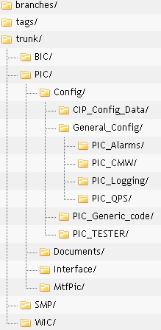
Figure 13 - The INTERLOCKS repository
Looking at Figure 12, the config files are in the following folders:
Folder | Comments
PIC_Alarms | config files for the Laser managers.
PIC_CMW | config files for the CMW managers.
PIC_Logging | config files for the LHC logging.
PIC_QPS | config files for the QPS managers.
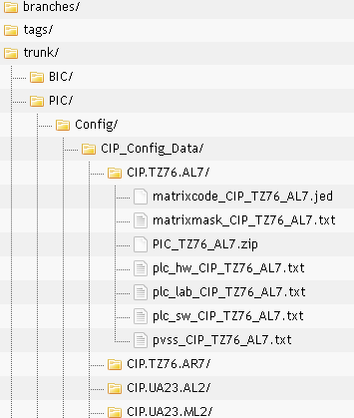
Figure 14 - Config files per circuit
Folder | Comments
Pvss_CIP_T276_AL7.txt | config files for the PVSS (devices to be imported)
plc_* | PLC related filest
matrix* | external controller code.

DpType description

CIPC DpType
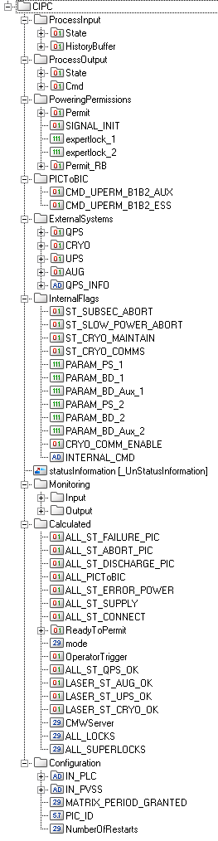
Results of External Systems status.
DISABLE = mask
Check Configuration dpe
All Calculated values
CIP Monitoring bits
CIP parameters
CIP Global variable
Signals sent to BIS
Give/Remove commands + Locks
PLC I/O + PVSS to PLC FA/DR commands
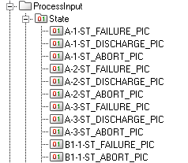
Detail of Input status: Interlock type-circuit number-signal name

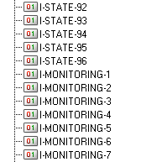
Detail of History Buffer: direction-data type-index

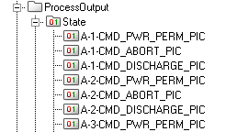
Detail of output status: Interlock type-circuit number-signal name

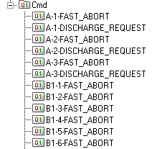
Detail of output CMD: Interlock type-circuit number-signal name

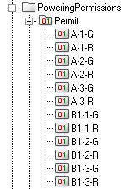
Detail of PIC CMD: Interlock type-circuit number-G/R permit

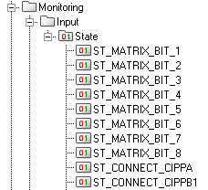
Detail of Monitoring bits: signal name

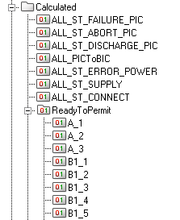
Calculated values: signal name

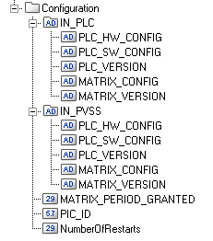
Check Configuration dpe

CIPC_CMD DpType description
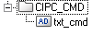
Dpe used to receive CMW QPS cmd (HDS)

CIPC_CRYOOK DpType description
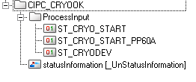
Dpe used to receive CMW CRYO status

CIPC_QPSOK DpType description
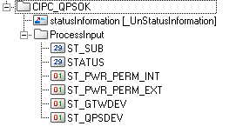
Dpe used to receive CMW QPS status

Interlocking flow chart

