LHC- - - 1999-09-22
Piquet Documentation
POWERING INTERLOCK SYSTEM:
SYSTEM DIAGNOSIS
Abstract

This document describes how to use the SCADA system of the Powering Interlock System and how to diagnose the different problems can appear.
Prepared by :  I. Romera TE/MPE  M. Zerlauth TE/MPE |  |  | Checked by : |  | Approved by :
History of Changes
Rev. No. | Date | Pages |  | Description of Changes
0.1 | 2011-05-20 | ALL |  | New document
Table of Contents

1. PVSS 4
1.1 HOW TO CONNECT TO PVSS 4
1.2 OVERVIEW SCREEN 5
1.3 HISTORY BUFFER SCREEN 7
1.4 DETAILED SCREENS 7
1.4.1 I/O STATUS 8
1.4.2 POWERING 9
1.4.3 MONITORING 10
1.4.4 PARAMS 11
2. FAILURE CATALOG and DIAGNOSTICS 12
2.1 COMMUNICATION PROBLEMS 12
2.2 CABLE CONNECTIONS 12
2.3 POWER SUPPLY FAILURES 13
2.4 FAULTY CURRENT SOURCES 13
3. Works Cited 16
4. APPENDIX - PIC LAYOUT 17

Table of Figures

Figure 1: Remote Desktop Connection window 5
Figure 2: LHC Shortcuts window 5
Figure 3: Symbol and colour-code conventions 6
Figure 4: PIC PVSS main screen 7
Figure 5: History buffer screen 8
Figure 6: I/O Status screen 9
Figure 7: Powering screen 10
Figure 8: Monitoring screen 11
Figure 9: Params screen 12
Figure 10: Lost Communication widget 13
Figure 11: PING command – cfp-ua23-cipal3 not reachable 13
Figure 12: Cable Connection status panel 14
Figure 13: Power supplies status of the PIC 14
Figure 14: Power supply boxes in CIPS module 14
Figure 15: Typical Powering Failure Loop 15
Figure 16: Current sources in CIPI module 15
Figure 17: Optocouplers in CIPA module 16

PVSS

HOW TO CONNECT TO PVSS

- Open Remote Desktop Connection on “CERNTSAB22”.

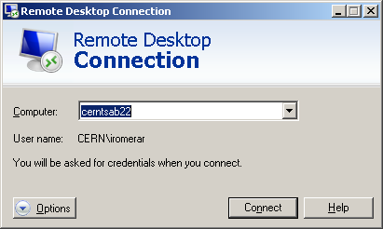

                - Figure 1: Remote Desktop Connection window

- Double click on “PVSS_Shortcut” on the desktop.



- On the PIC tab, click on “1 SCREEN” button.

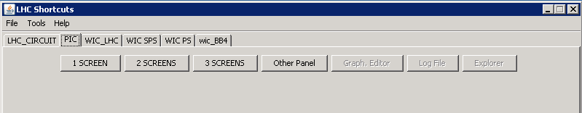
                - Figure 2: LHC Shortcuts window

OVERVIEW SCREEN
In the main screen we have an overview (see Figure 4) of the status of all 36 Powering Interlock Controllers (PIC) in the LHC accelerator complex. Each box in the layout diagram describes a single PIC and can be represented with the following symbol and colour convention:


Symbol | Description
O | Old data (no connection with front end)
F | Forced mode (some signals masked)
A | ST Error or ST_Power failure
S | Failure on ST supply
C | ST_Connect failure
M | Multiple failures

Colour | Description
Green | All OK
Orange | Bad status of Maskable User Permit to BIS
Red | Bad status of Powering Subsector OFF or Bad status of Unmaskable user Permit to BIS
Cyan | Old data (no connection with front end)
Purple | Device does not exist
                - Figure 3: Symbol and colour-code conventions

In addition we have a global overview of interlocks masking, sector access, electrical circuits locking or last post-mortem trigger.
- CIP MASKED INFO: It contains information about the mask status of CRYOGENICS, QPS, UPS, AUG or configuration checks.
- POST MORTEM INFO: It indicates the last time that the PIC was involved in a beam dump request.
- CIRCUITS INFO: It keeps a track of the list of circuits which are locked and that cannot be powered.
- PP60A: It provides the status of the Power_Permit 60A in all sectors.
- SECTOR ACCESS: It shows the status of SECTOR_ACCESS signals which limit the current below 1kA to allow for short access.

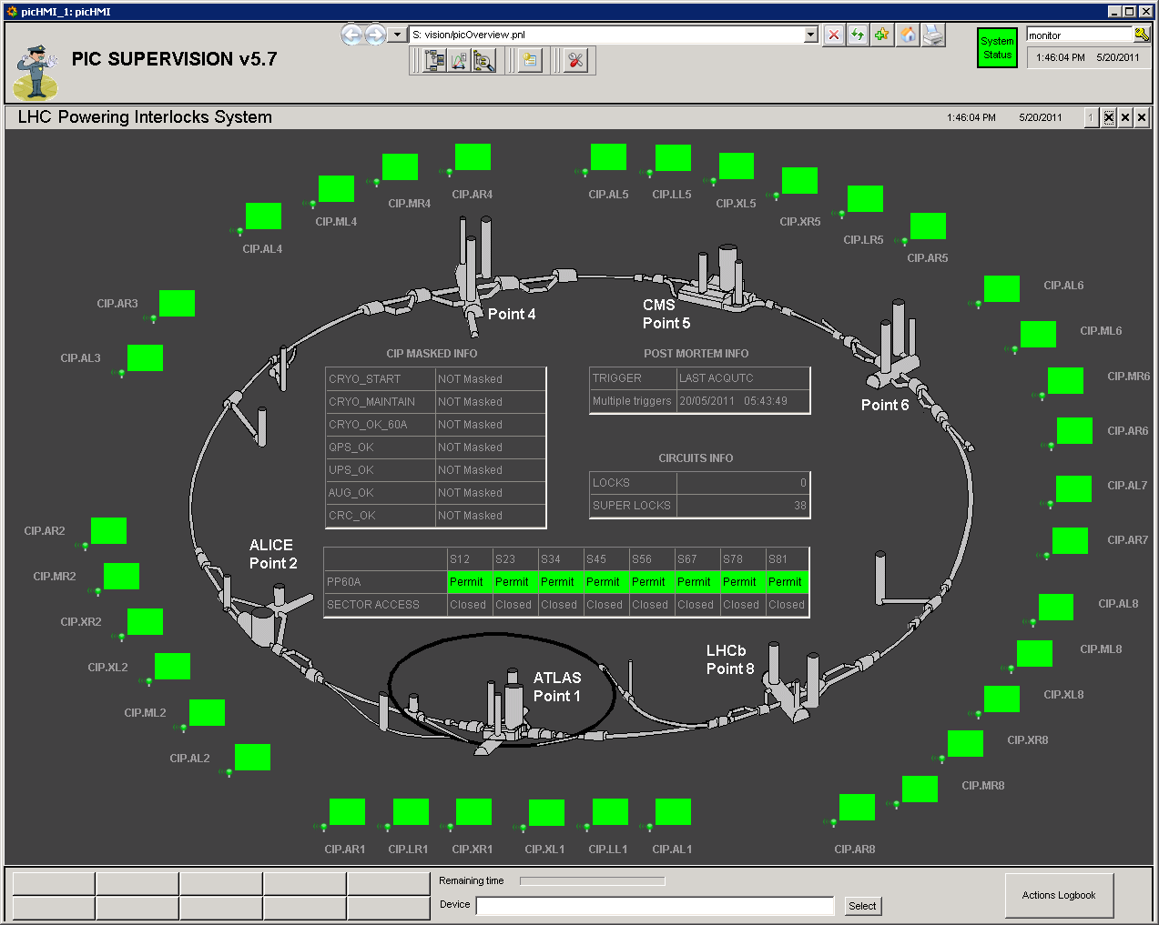
                - Figure 4: PIC PVSS main screen

HISTORY BUFFER SCREEN
The history buffer of the PIC can be launched from the overview screen.
From this window we can retrieve the logs of the PICs within a specified time window and applying different filter options.

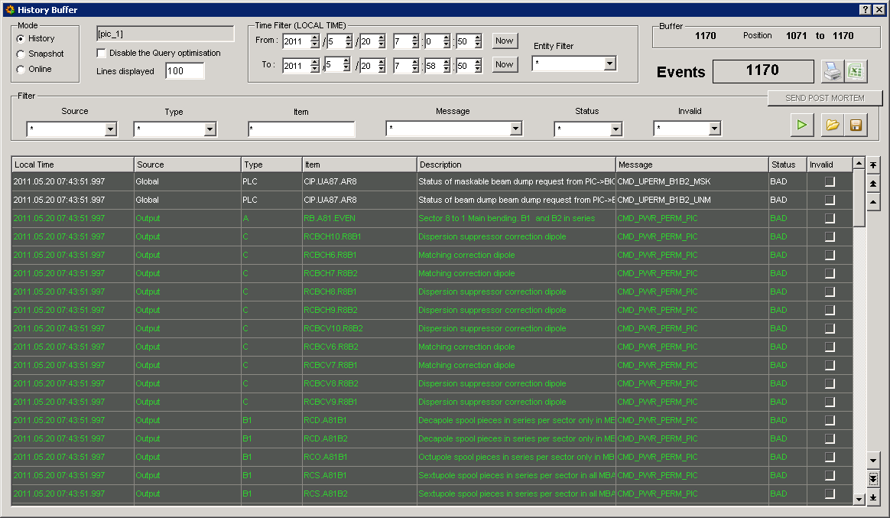
                - Figure 5: History buffer screen

DETAILED SCREENS
By clicking on the square box of a specific PIC on the main screen a detailed view of such PIC will be opened.

I/O STATUS

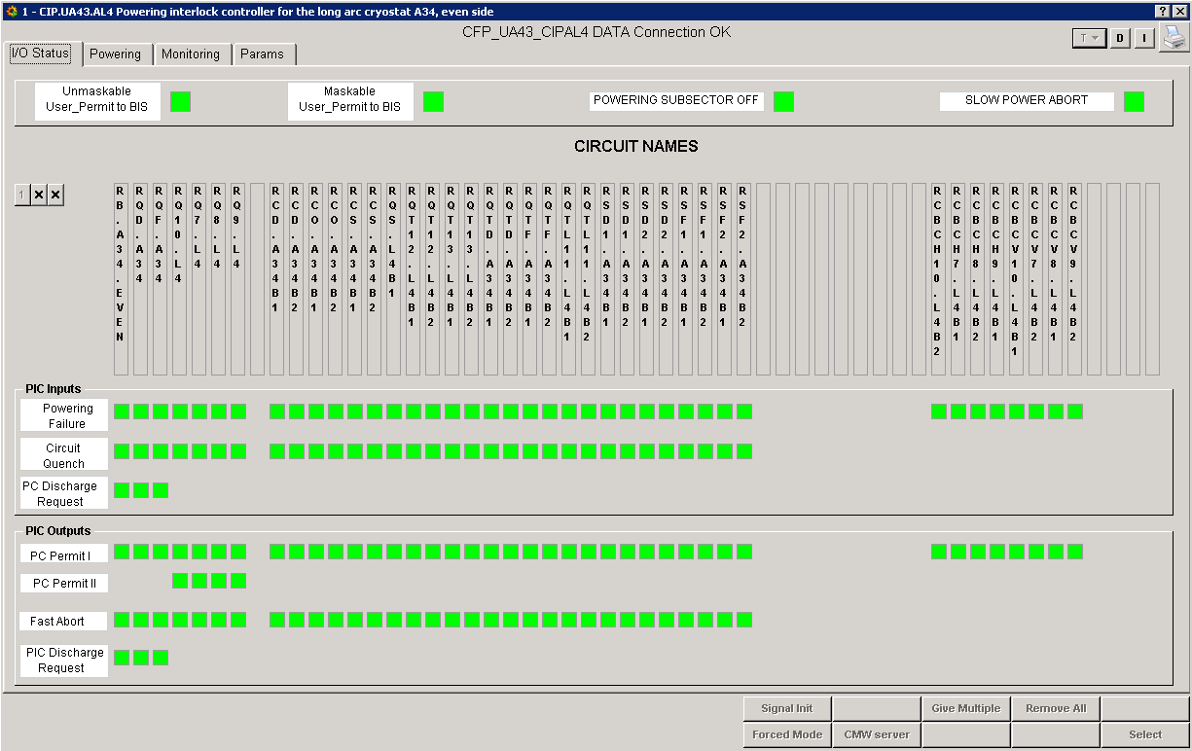
                - Figure 6: I/O Status screen
Unmaskable User_Permit to BIS: Status of the USER_PERMIT sent to the Beam Interlock System (BIS) when a powering failure is detected in at least one of the circuits considered as essential for beam operation.
Maskable User_Permit to BIS: Status of the USER_PERMIT sent to the BIS when a powering failure is detected in at least one of the circuits considered as auxiliary for beam operation.
Powering Subsector OFF: Status of the global powering subsector abort.
Slow Power Abort: Status of the global slow power abort.

POWERING
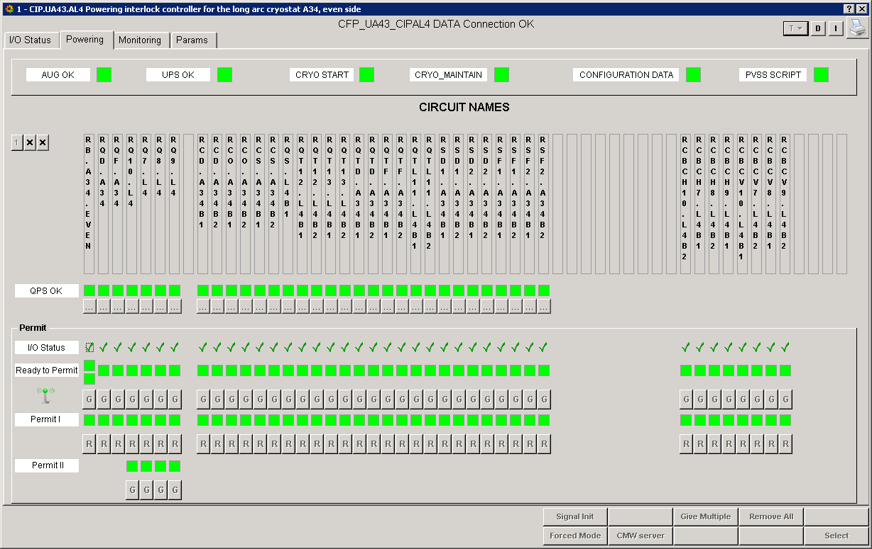
                - Figure 7: Powering screen
AUG OK: Software signal which represents the status of the AUG sytem.
UPS OK: Software signal which represents the status of the UPS system.
CRYO START: Software signal representing the status of the CRYO and required before starting powering. If CRYO_START signal is lost during operation, powering will continue normally.
CRYO MAINTAIN: Signal representing the status of the CRYO. This signal arrives to the PIC via PLC to PLC communication and in case of losing it, a slow power abort will be initiated in the powering subsector.
CONFIGURATION DATA: Signal that detects inconsistencies in the configuration data of the PLC against PVSS.
PVSS SCRIPT:

MONITORING
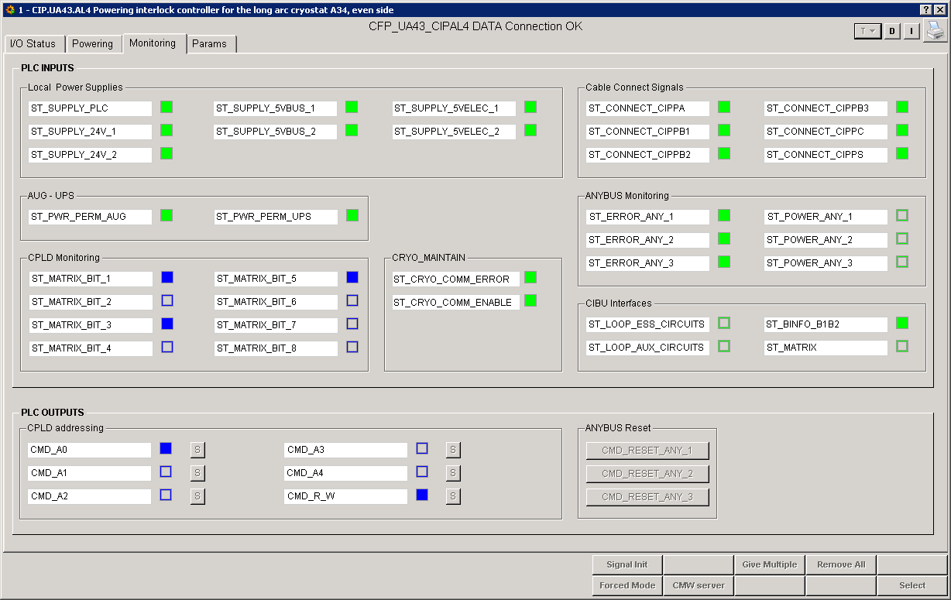
                - Figure 8: Monitoring screen
Local Power Supplies: It represents the status of all power supplies in the PIC.
Cable Connect Signals: It shows whether all expected cables arriving to the patch panels of the PIC are connected.
AUG – UPS: It shows the status of the hardware signal arriving from the AUG and UPS systems to the BIC.
ANYBUS Monitoring: It shows the status of the ANYBUS modules which interface the remote I/O and the PLC via PROFIBUS.
CPLD Monitoring: It gives back the data addressed by CPLD addressing.
CRYO MAINTAIN: It shows the status of the communication with the CRYO PLC.
CIBU Interfaces: It shows the status of the USER_PERMIT of the essential and auxiliary circuits to the BIC.

PARAMS
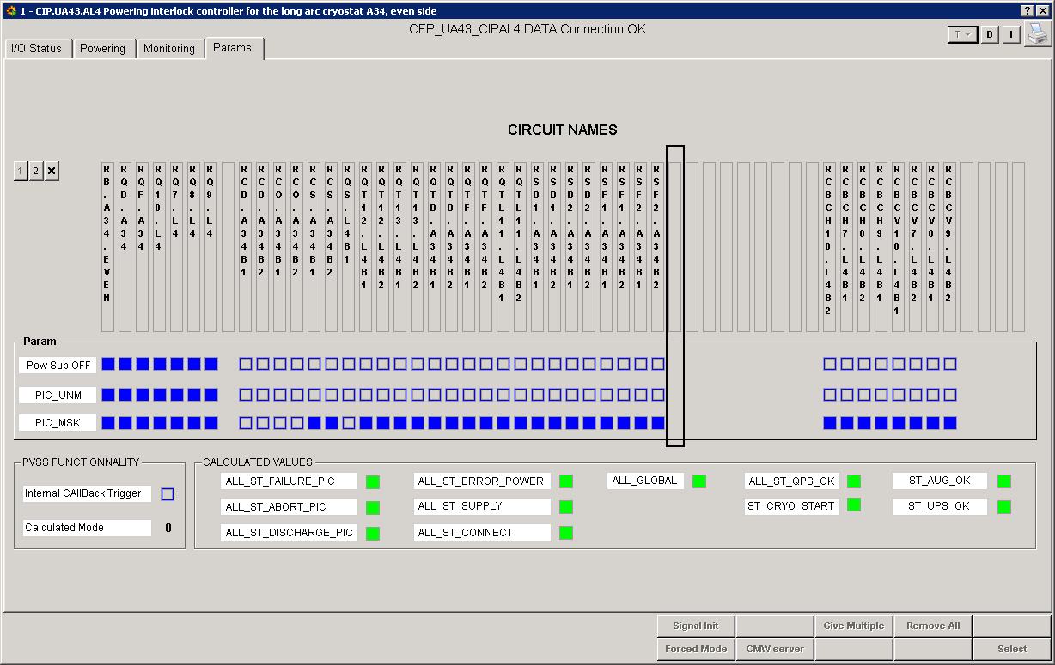
                - Figure 9: Params screen
Pow Sub OFF: It represents the list of circuits which can trigger a Powering Subsector Abort.
PIC_UNM: It shows the list of essential circuits.
PIC_MSK: It shows the list of auxiliary circuits.

FAILURE CATALOG and DIAGNOSTICS
The most common problems we can find are described below.

COMMUNICATION PROBLEMS
A communication problem with a controller (PLC) can be caused by various reasons, amongst of them are:
- Memory corruption of PLC (occurred in the past due to SEUs on electronics)
- Infrastructure issues (Ethernet routers, electricity supply, etc)

To diagnose this kind of problem we can use the following methods:

- In PVSS we will find the PIC with communication problems represented with a blue square with an “O” (Old data, no connection with front end).



                - Figure 10: Lost Communication widget
- In MOON, an error will appear in the following parameters: “Successfully connected to PLC” and “PLC successfully reply”.

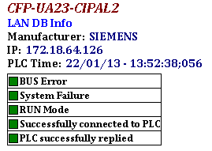
                - Figure 11: Moon diagnostic tool
- By using ping command, we need to type the name of the PIC in MS-DOS console (be sure that you launch the command from a computer connected to the TN).

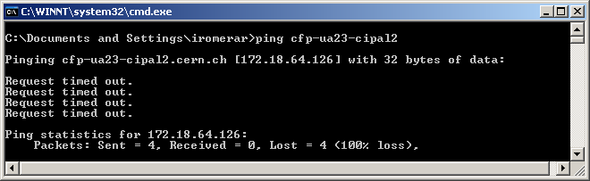
                - Figure 12: PING to cfp-ua23-cipal2 (not reachable)
If the communication problem is caused by the network infrastructure, we can only contact network.support@cern.ch. However, if the problem is due to some internal latch-up of the PLC, a power cycle could solve it.

To do a power cycle of the controller we need to connect using putty to “cs-ccr-dev1” and type rem_reset “name_of_the_controller”.

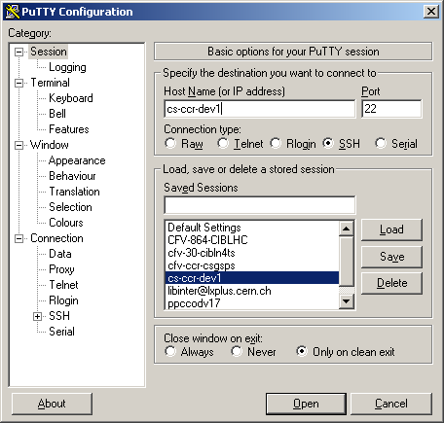
                - Figure 13: ssh connection to cs-ccr-dev1

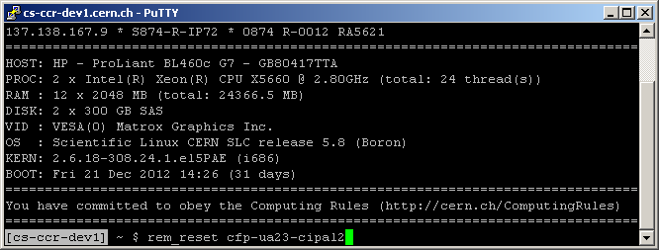
                - Figure 14: Remote reset of cfp-ua23-cipal2

CABLE CONNECTIONS
An easy way to verify that all cables are connected to the Powering Interlock Controller is by checking the “Monitoring” tab in PVSS. In the section “Cable Connect Signals” we can verify the status of the connections. Green color means that all cables are connected to the patch panels and the current loops of the ST_CONNECT signals are closed. See (R.Schmidt, 2007) for detailed signals pin-out.
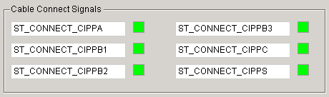
                - Figure 15: Cable Connection status panel

POWER SUPPLY FAILURES
In case of power supply failures an “S” symbol will appear near the PIC box in the overview screen. Moreover, on the “Monitoring” tab we will find more detailed information about the faulty power supply. See (M.Zerlauth, CIPS Schematics, 2004)

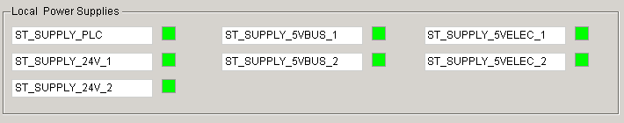
                - Figure 16: Power supplies status of the PIC
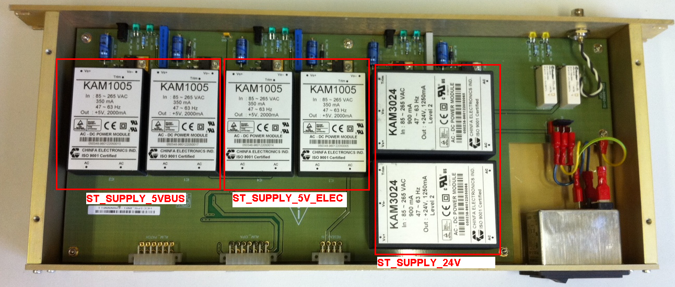
1
2
2
1
2
1
                - Figure 17: Power supply boxes in CIPS module

FAULTY CURRENT SOURCES
Current sources are widely used in the PIC to exchange the required protection signals for an electrical circuit. The loops are typically driven by a voltage between 15V and 24V and the current should be between 10mA and 20mA.
An example of current loop is the Powering Failure Loop (R.Schmidt, 2007) which represents a direct connection between the PIC and the power converter (PC). If the PIC stops supplying current to the loop, no current will circulate and therefore the PIC will detect a Powering Failure.

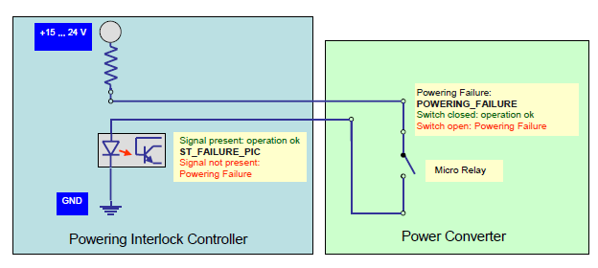
                - Figure 18: Typical Powering Failure Loop

If after having reset a power converter (switch closed), a powering failure signal is still detected, the problem can be due to either a faulty current source on the PIC side or a faulty optocoupler in charge of reading the status of the loop.

- Faulty current source: Review document (M.Zerlauth, CIPI Schematics, 2009)

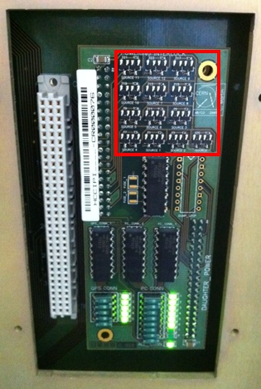
                - Figure 19: Current sources in CIPI module

- Faulty opto-coupler: Review document (M.Zerlauth, CIPAA Schematics, 2004)

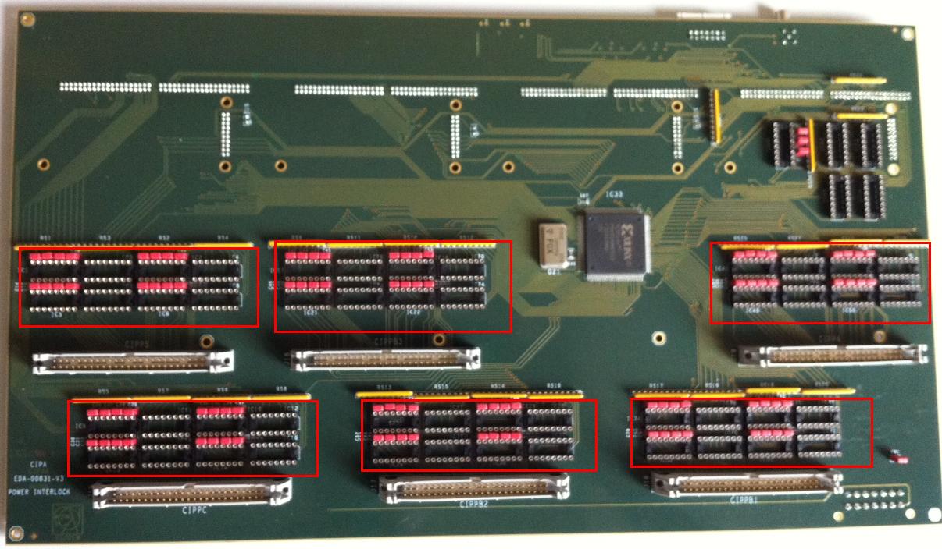
                - Figure 20: Optocouplers in CIPA module
Same diagnostic principles must be applied to UPS, AUG and BIC which use current loops.

Works Cited
M.Zerlauth. (2004). CIPAA Schematics. Retrieved from https://edms.cern.ch/file/498784/3/EDA-00831-V3_sch.pdf
M.Zerlauth. (2004). CIPAB Schematics. Retrieved from https://edms.cern.ch/file/701906/1/EDA-01288-V1_sch.pdf
M.Zerlauth. (2009). CIPI Schematics. Retrieved from https://edms.cern.ch/document/639831/3.0
M.Zerlauth. (2004). CIPS Schematics. Retrieved from https://edms.cern.ch/nav/EDA-00892%26expand_open=Y
R.Schmidt, B. M. (2007). THE HARDWARE INTERFACES BETWEEN POWERING INTERLOCK SYSTEM, POWER CONVERTERS AND QUENCH PROTECTION SYSTEM. Retrieved from https://edms.cern.ch/file/368927/3.0/LHC-D-ES-0003-30-00.pdf
Romera, I. (2013). http://pic.web.cern.ch. Retrieved from LHC Powering Interlock System: http://pic.web.cern.ch

APPENDIX - PIC LAYOUT


                 